EVNIRONMENTAL SETUP

|  |  |
| --- | --- |
| **Date** | **16 Oct 2022** |
| **Team ID** | **PNT2022TMID48083** |
| **Project Name** | **CUSTOMER CARE REGISTRY** |

FLASK SETUP:

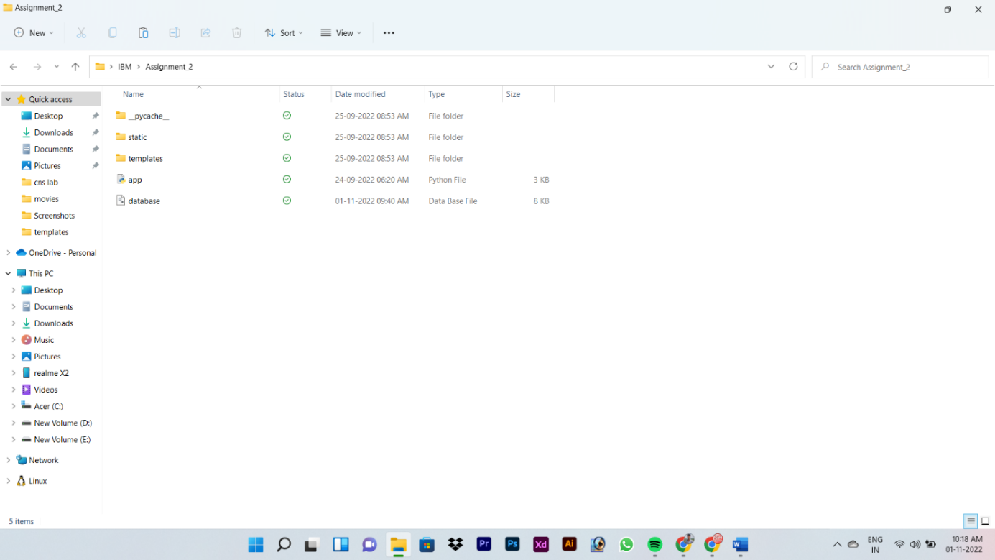

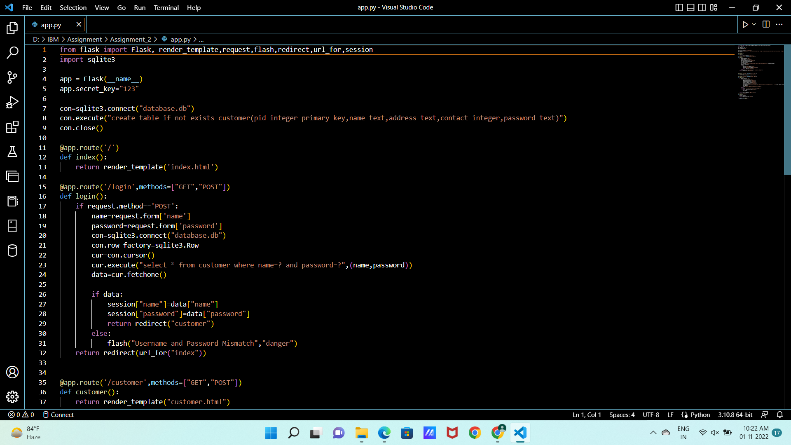

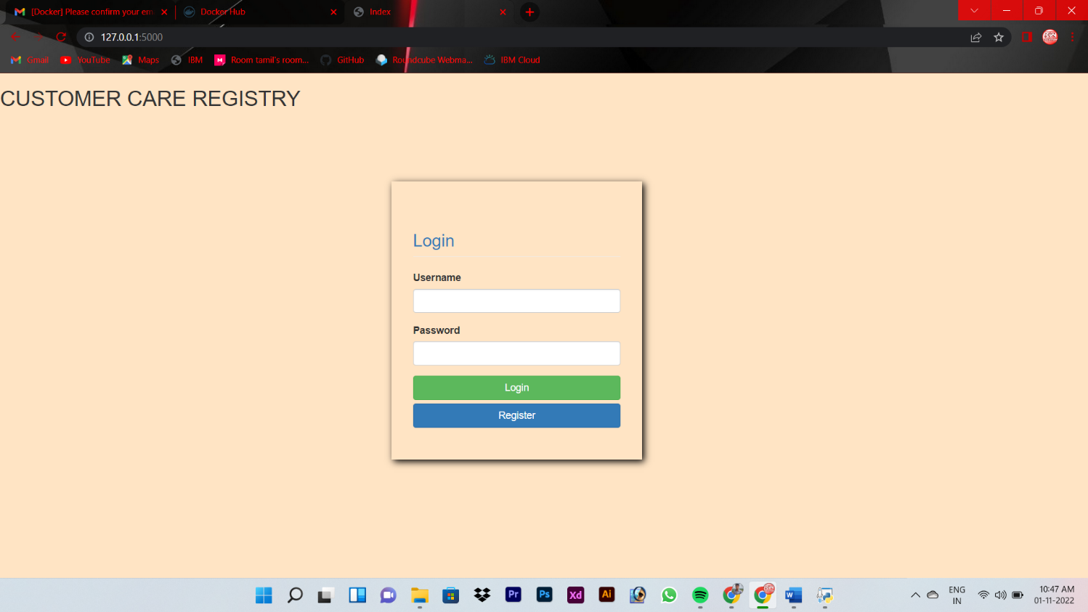

DOCKER SETUP:

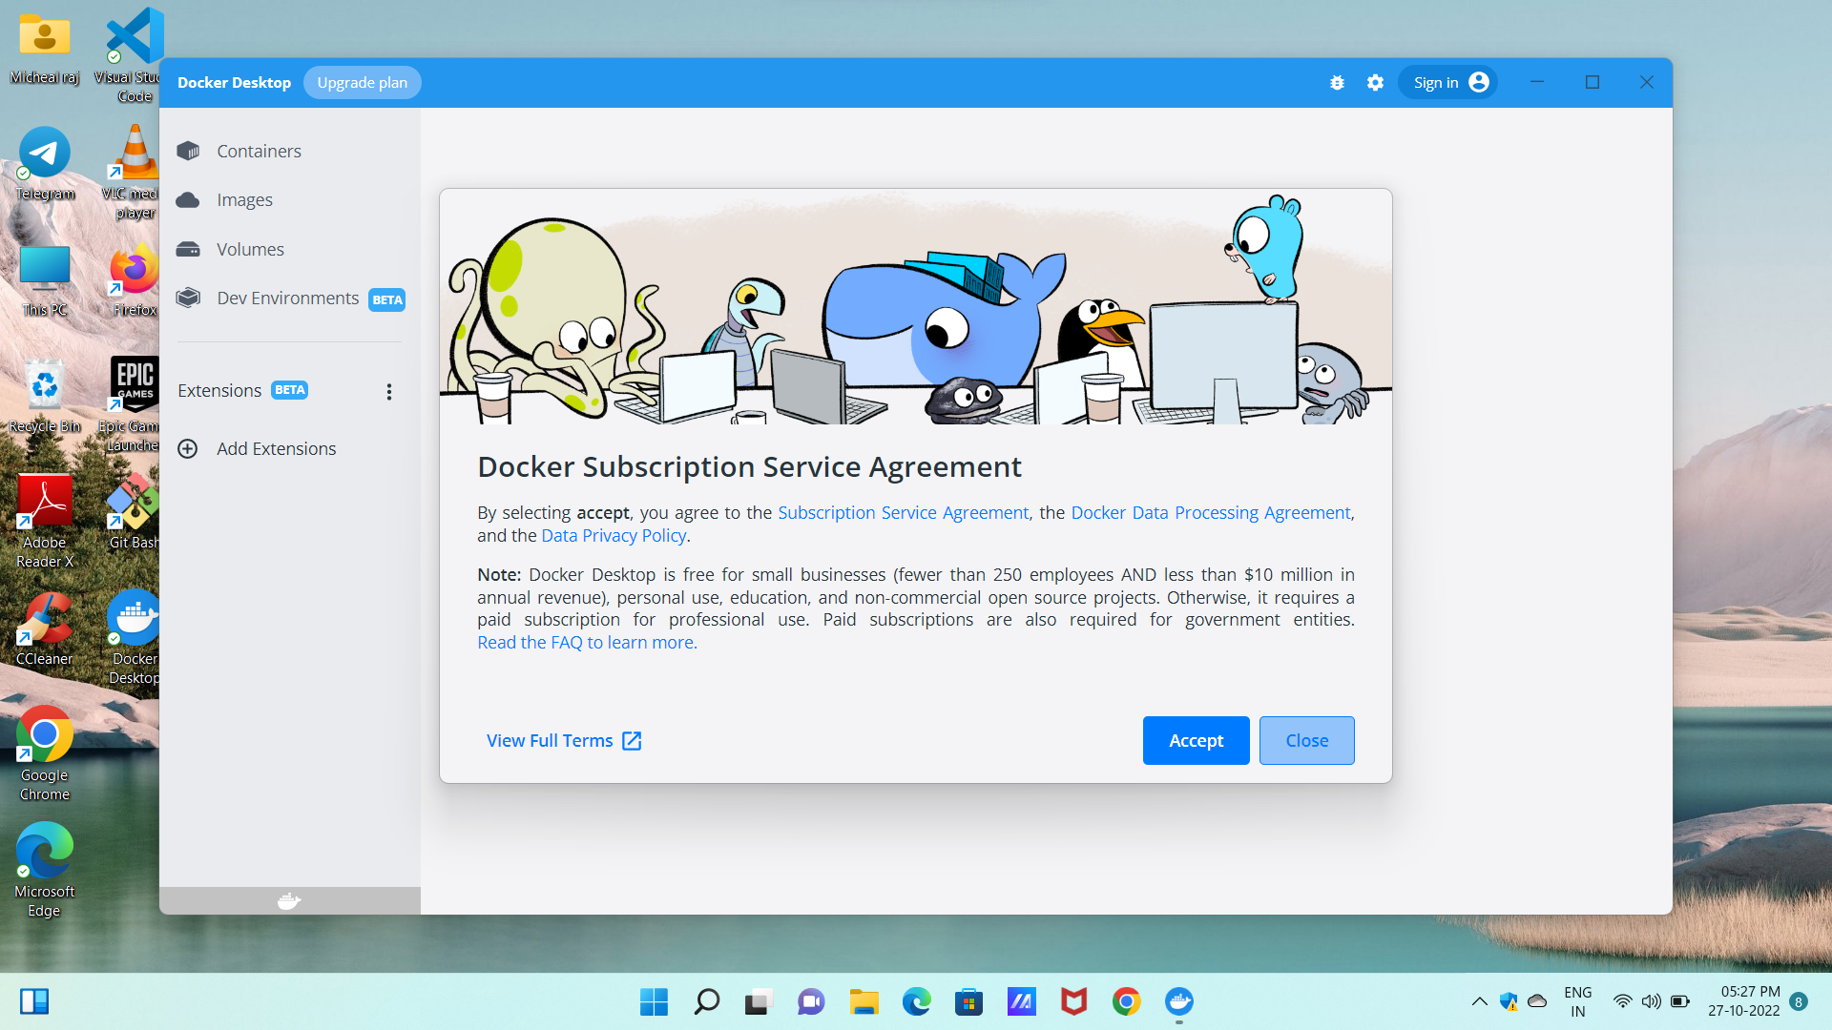

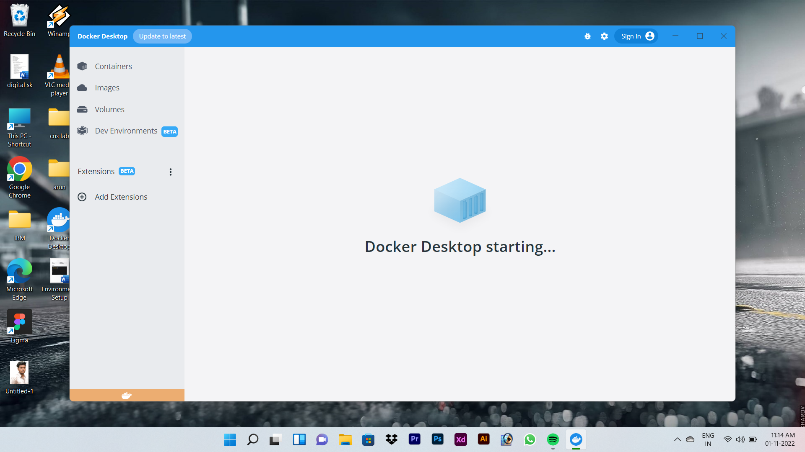

COLUD ACCOUNT CREATION:

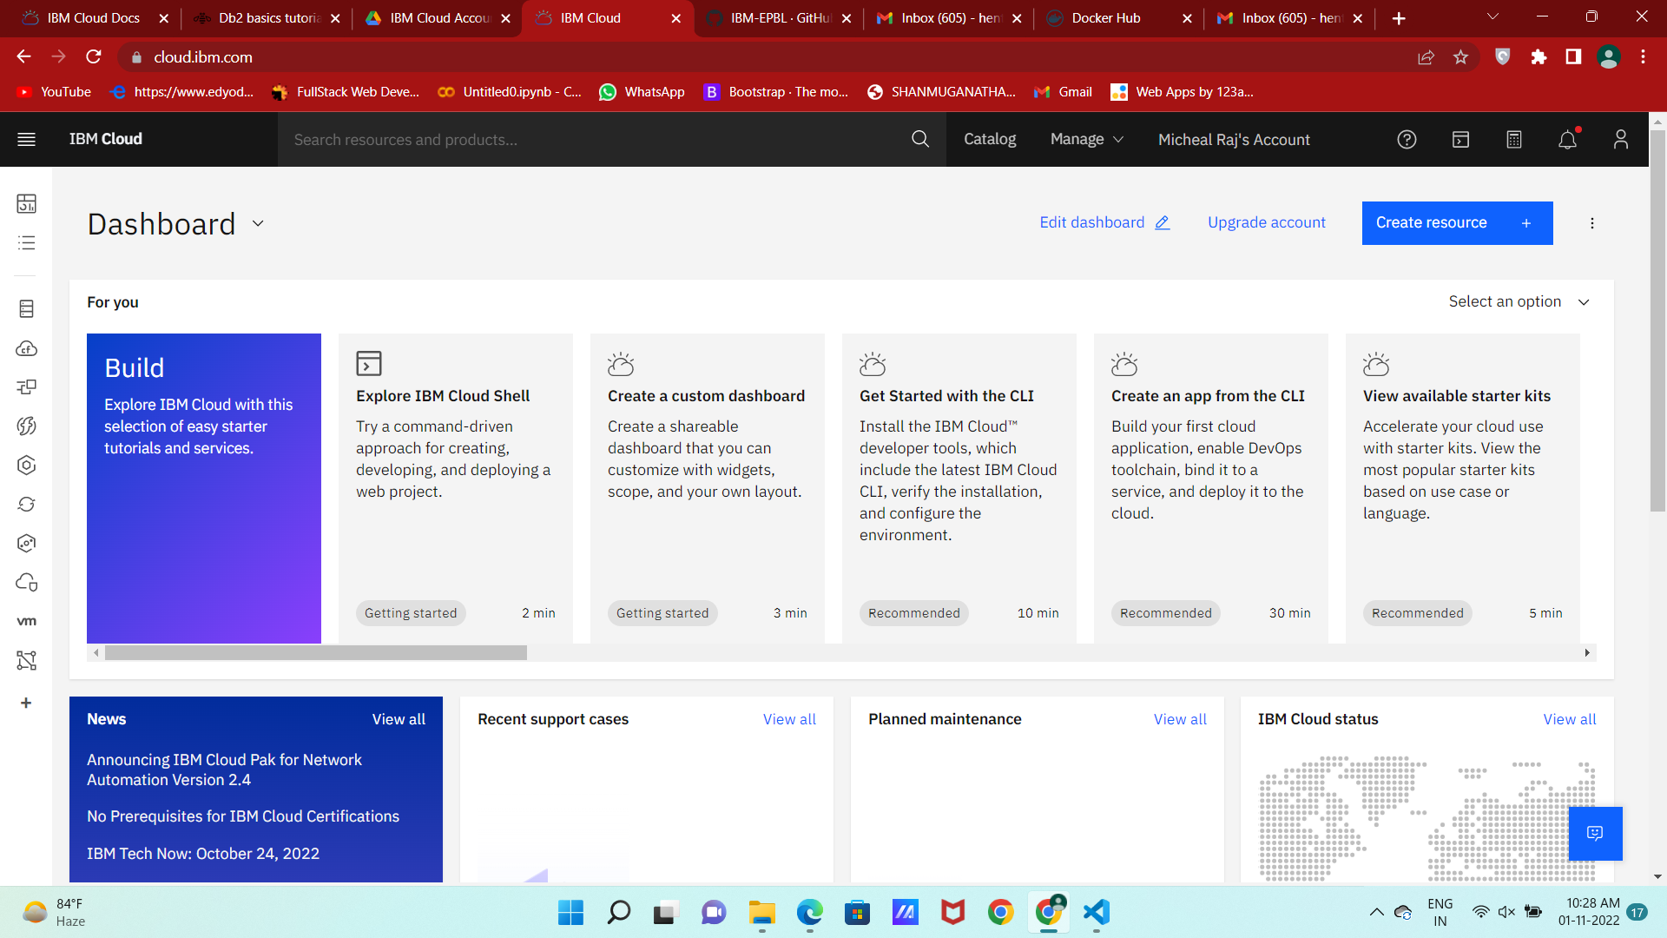

SENDGRID ACCOUNT CREATION:

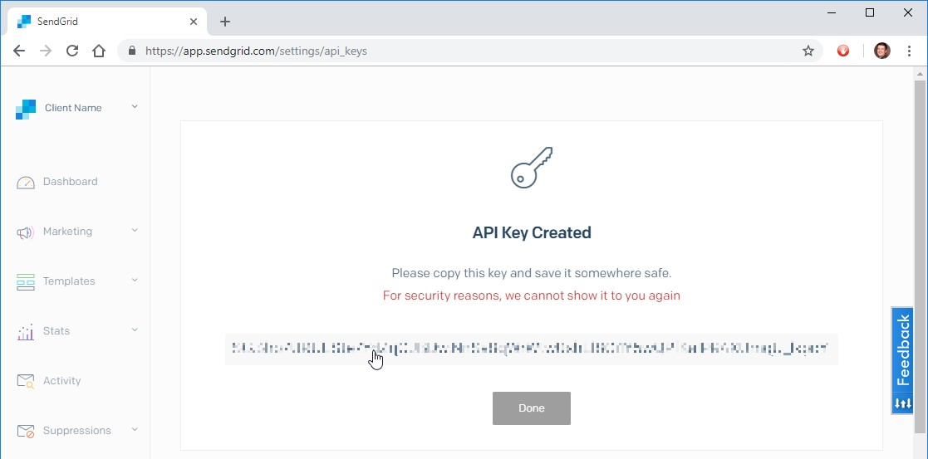

IBM CLOUD CLI INSTALL :

